INSTRUCTIONS

This form explains potential uses of student photographs and video images by the Wake County Public School System (WCPSS) and allows you to grant or deny permission to the WCPSS to release your child’s image for display or publication.

Yearbook and class photos are handled separately. If you do not want your child to be in the class photographs or yearbook, contact the school directly.

This form also allows a parent or guardian the choice whether or not their student may be identified by name on the school or district’s Internet websites. Student names may be released unless a parent or guardian has expressly contacted the school and requested that their student’s “directory information” not be shared. However, as a safeguard, the district does not directly publish student names to the Internet unless given permission by a parent or guardian.

The WCPSS uses internal and external media to highlight the K-12 experience in a variety of ways, which may include the use of photographs and videos of students. For example, student images may be published or displayed in printed materials (such as brochures and newsletters), videos, school websites, and information about school events and activities provided to external organizations and media outlets. Parents have two options for granting or denying consent:

- Parents may deny permission for any display or publication of their student’s image. You should select this option if you do not want your student’s photograph to be used on the WCPSS or individual school websites, in WCPSS or school publications, or in release to external organizations (such as PTA and booster clubs) or the media.
- Parents also may grant permission for their student’s image to be published or displayed in print, video, and/or digital media. Selecting this option means that your student’s photograph and name may appear in WCPSS or school publications, on the WCPSS or individual school websites, and may be released to external organizations (such as PTA and booster clubs) or the media.

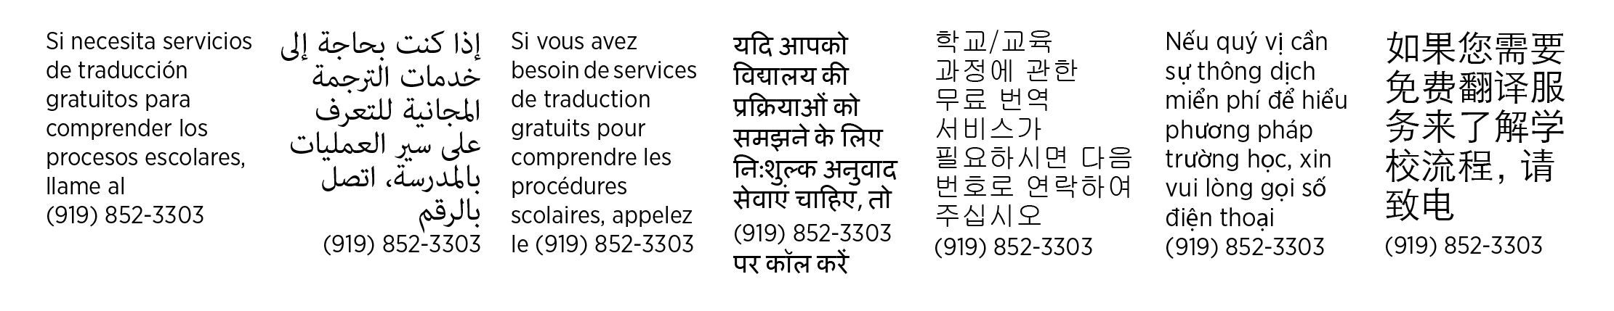
Please complete this form and have your student return it to his or her school. This consent form remains valid throughout your student’s K-12 experience with the Wake County Public School System or until a new form is completed and signed by a parent/guardian or eligible student.

CONSENT FOR NAME, PHOTO AND VIDEO
Student’s Legal Last Name | Student’s Legal First Name | Student’s Legal Middle Name

Photo/Video Release

I deny permission to use my child’s image for display, publication or release to external organizations.

I grant permission for use of my child’s image in print, video and/or digital media. I understand that my child’s image may be used or released by the WCPSS without additional notification and that my child’s name may appear along with his or her photograph.

Name Release

I grant permission for my child to be identified by name on the school or district’s Internet websites.

I deny permission for my child to be identified by name on the school or district’s Internet websites.

Name of Parent/Guardian (or student, if over age 18)
Signature |  | Date (mm/dd/yyyy)

